Hardware to Software Trigger BOX

## Overview

This document describes the main features of the Hardware To SoftwareTrigger Box, used in Bella control system, in order to generate a multicast TCP trigger for those devices that do not support a hardware trigger.

## System Schematic

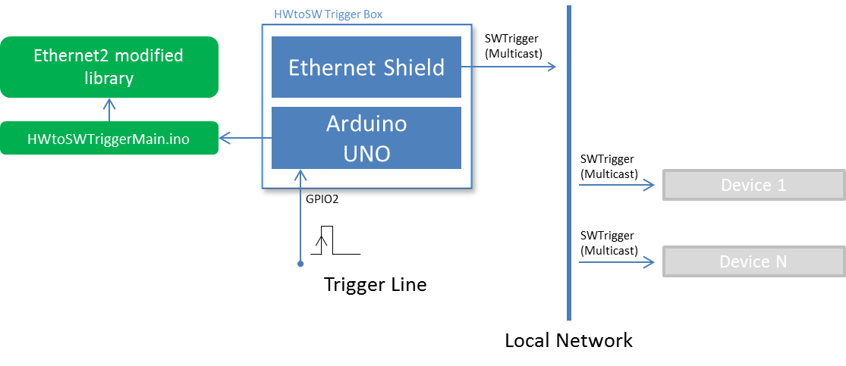

## Timing

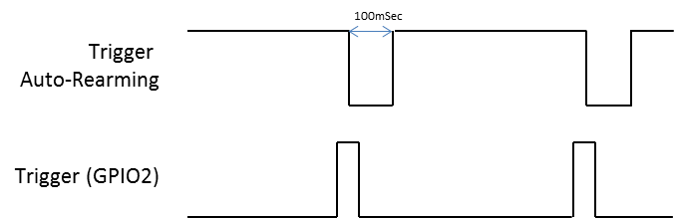

## Specifications

|  |  |
| --- | --- |
| **Network** |  |
| Arduino Local IP | 192.168.14.41 |
| Multicast IP | 234.5.6.16 |
| Multicast Port | 58455 |

|  |  |
| --- | --- |
| **Electric** |  |
| GPIO2 input impedance | 100MOhm* |
| GPIO2 input signal amplitude voltage | 3.5 to 5V |

*Note: a 10KOhm Pulldown resistor is required if the input is disconnected

## Resources

Sourcecode and support libraries available at  
 .*./Device Drivers/Arduino Developments/HWtoSWTriggerBox/*